12/01/2021

**DML Operation**

1. update employees set salary = 8000 where employee_id=115 and salary<6000; desc employees;

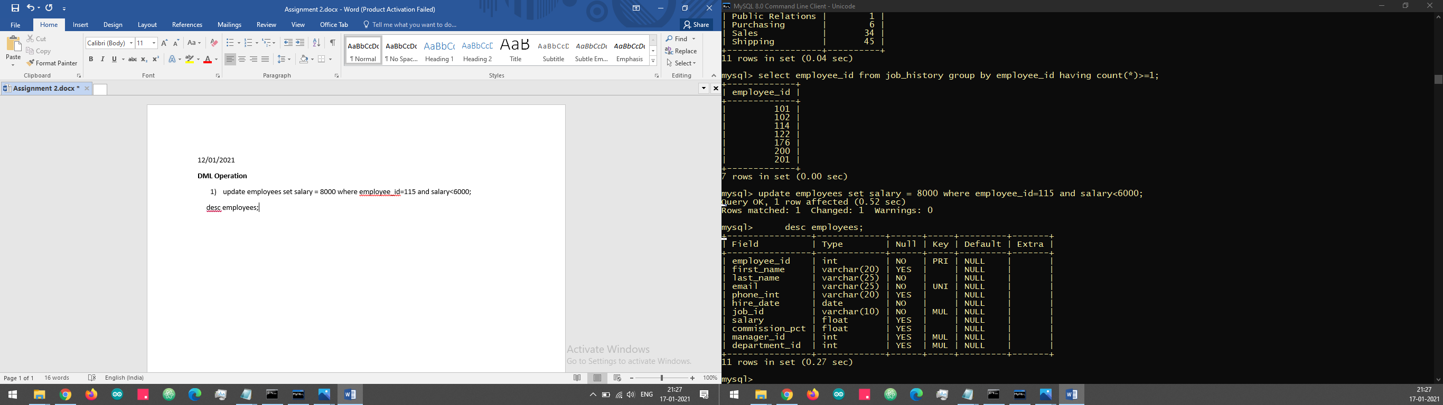

1. insert into employees(employee_id,first_name,last_name, email,phone_int,hire_date,job_id,salary,department_id)values(222,'xxx','yyy','zzz','111 55 542',2018-08-02,'IT_PROG',20000,50);

3)

4) update employees set job_id='IT_PROG' where employee_id=110 and department_id=10 and not job_id like 'IT%';

desc employees;

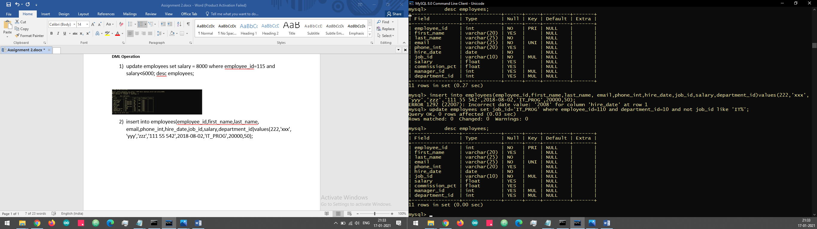

5)

6) select employee_id, job_title, end_date=start_date days from job_history natural join jobs where department_id=30;

**DDL**

1. create table Customer(custid int,firstName varchar(20) not null,lastName varchar(20),age int,city varchar(20),mobileNumber int,dob date,constraint c_pk primary key(custid),constraint a_pk check(age>21),constraint p_pk unique(mobileNumber));
2. create table Branch(branchId int,branchName varchar(20) not null,city varchar(20) not null,constraint b_pk primary key(branchId));
3. Create table Account(accountNumber varchar(20),openingBalance int,typeOfAccount enum('savings','current'),status varchar(20),bankid int,constraint a_pk primary key(accountNumber),constraint ob_pk check(openingBalance>5000),constraint bi_pk foreign key(bankid) references Branch(branchId));
4. Create table Account(accountNumber varchar(20),openingBalance int,typeOfAccount enum('savings','current'),status varchar(20),bankid int,constraint a_pk primary key(accountNumber),constraint ob_pk check(openingBalance>5000),constraint b_pk foreign key(bankid) references Branch(branchId));
5. Create table Loan(LoanId int,loanAmount int,customerId int,bankid int,constraint li_pk primary key(LoanId),constraint la_pk check(loanAmount>=0),constraint bi_pk foreign key(bankid) references Branch(branchId));

**Sub Query**

1. select * from departments where manager_id in (select employee_id from employees where first_name='john');

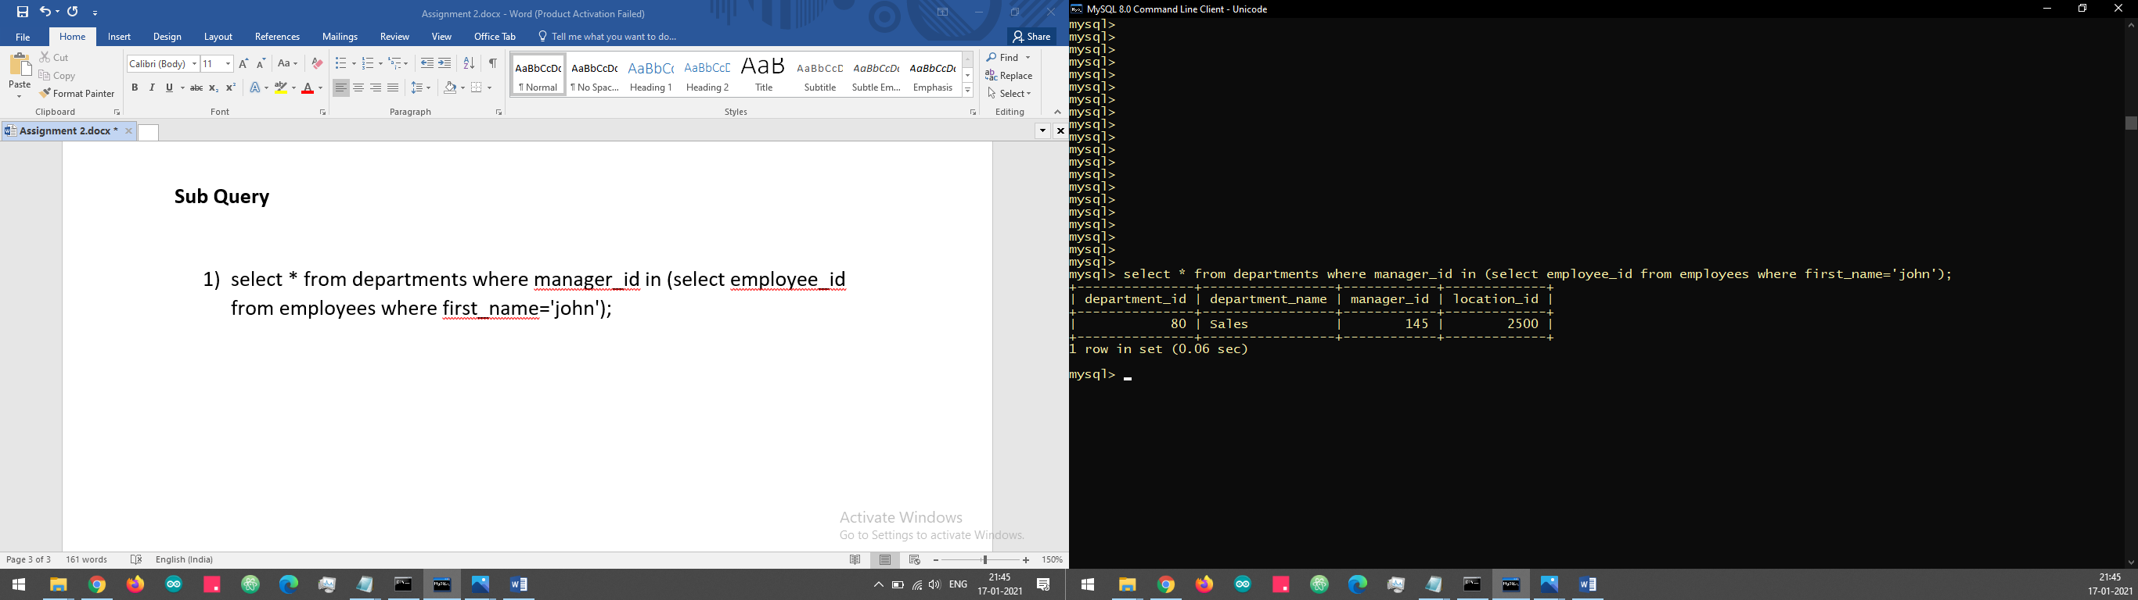

2) select * from employees where employee_id not in (select employee_id from job_history);

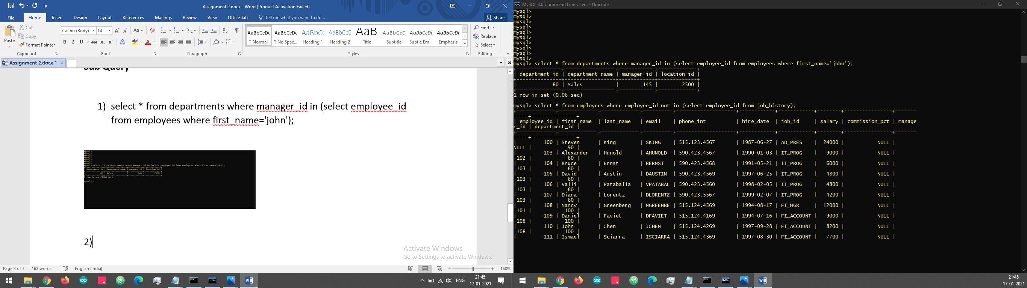

1. select job_title, avg(salary) from employees natural join jobs group by job_title;

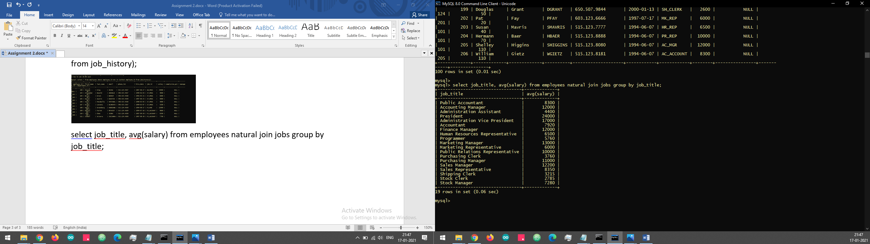

1. select country_name, city, count(department_id) from countries join locations using(country_id) join departments using(location_id) where department_id in (select department_id from employees group by department_id having count(department_id)>=2)group by country_name,city;

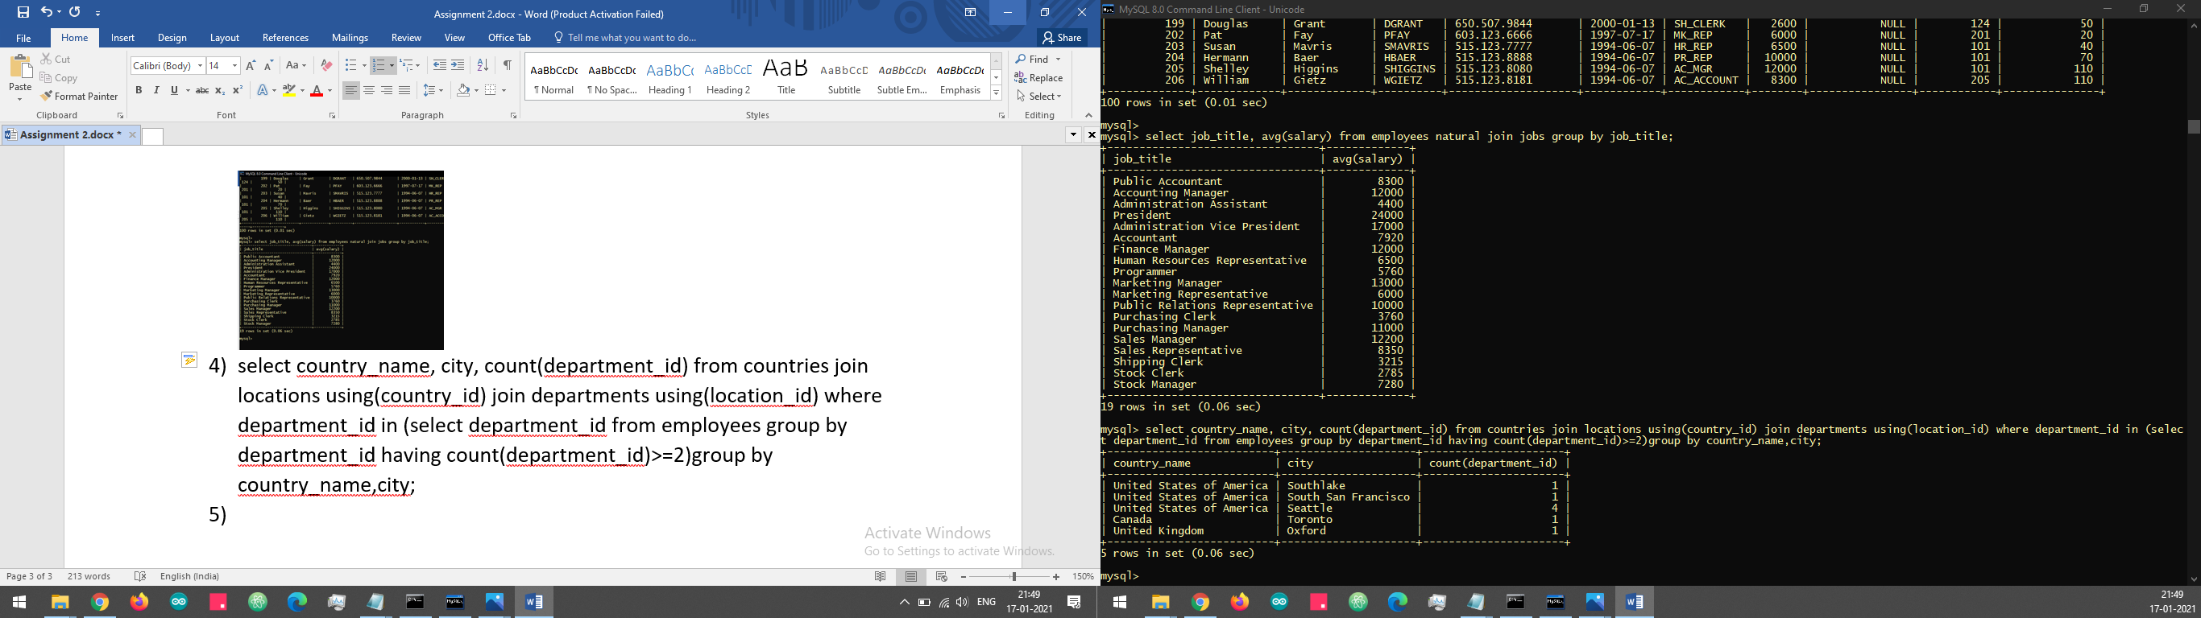

5)

1. select *from jobs where job_id in(select job_id from employees where employee_id in(select employee_id from job_history where job_id='IT_PROG'));

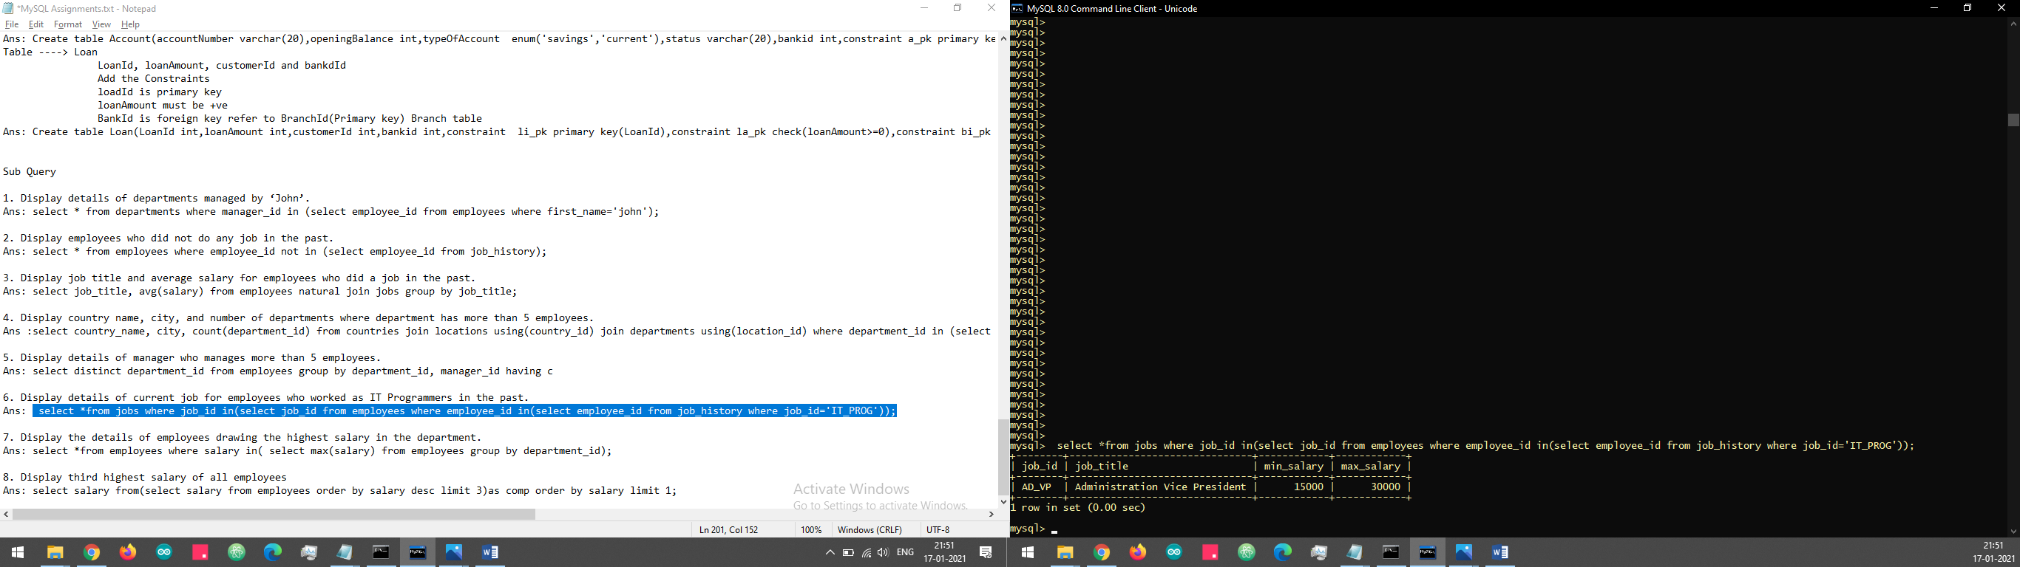

1. select *from employees where salary in( select max(salary) from employees group by department_id);

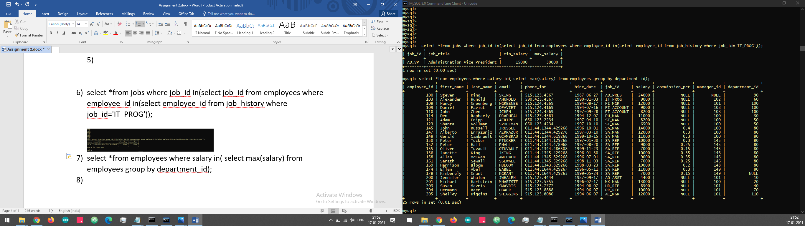

1. select salary from(select salary from employees order by salary desc limit 3)as comp order by salary limit 1;

